Q1.Explain output method in java programming?

Ans: if you want to display anything on the console window then we should go for output method in java programming

We use following output method in java

1. System.out.println(): print and change the cursor on new line
2. System.out.print(): print data on the console but it not change cursor on new line
3. System.out.printf(): print data on the console but it not change cursor on new line

The output method broken into 3 parts

1. System: Pre-defined class present in java.lang package
2. out: Pre-defined public static variables of PrintStream class inside the System class
3. println(): method defined inside the PrintStream() class

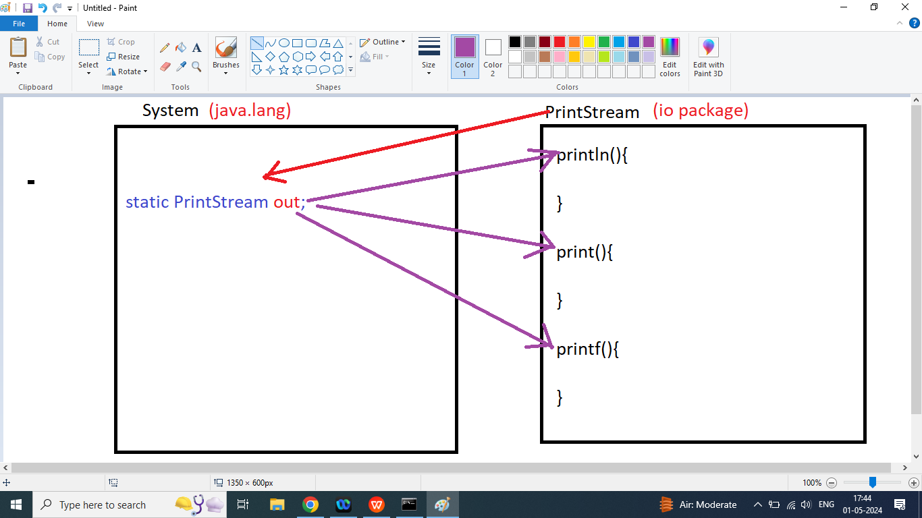

System.out.println(“Hello World”);

OR

System.out.print(“Hello World”);

OR

System.out.printf(“Hello World”);

Q2. Write a java program to print Hello World on the Screen

